IAM Task
1.Create one IAM user and assign EC2 and S3 full access roles.
First we should go to IAM.
We should click on create user and create name.
Now we should go to attach policies.
There we can search for EC2 and S3 full access permission policies and click on create.
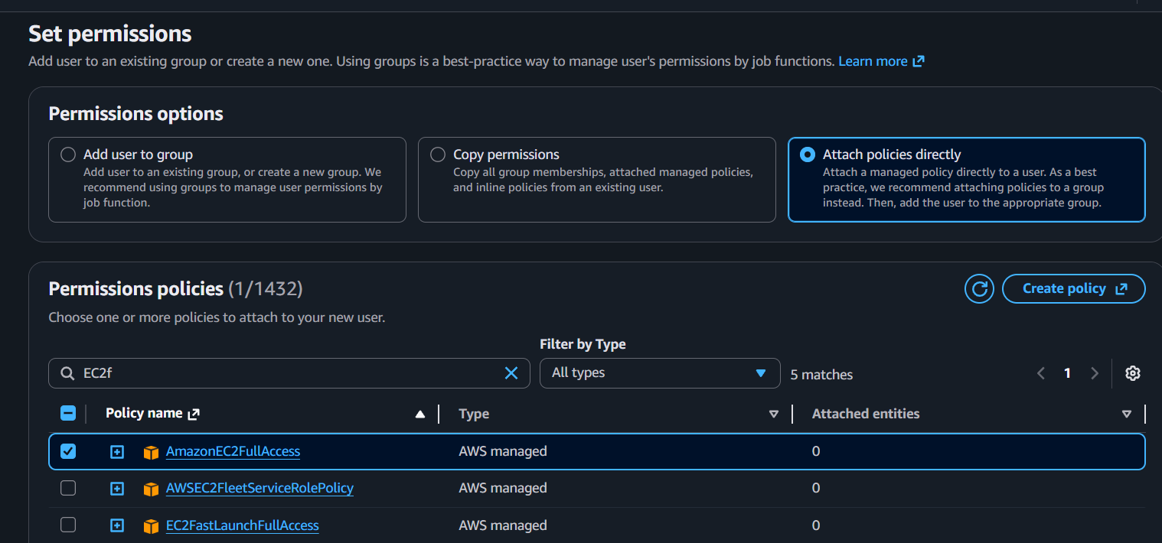
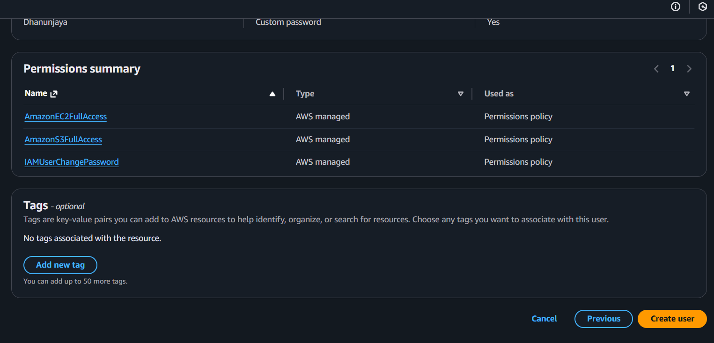
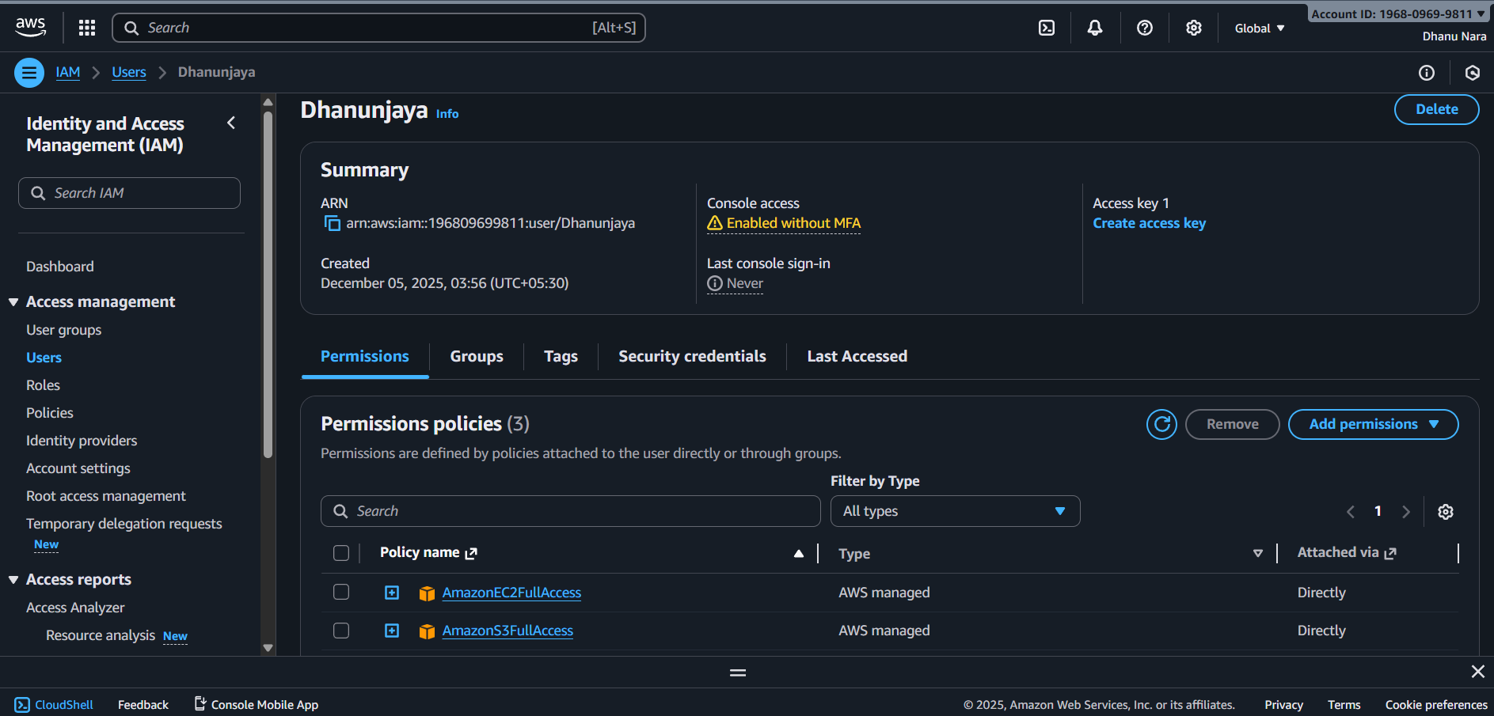

2.Create one group in IAM and assign read access for EC2.
First we should go to IAM.
Then we should go to user groups and click on create a group and also enter a name.
Now attach Read-only policy for Ec2.
Now click on create.
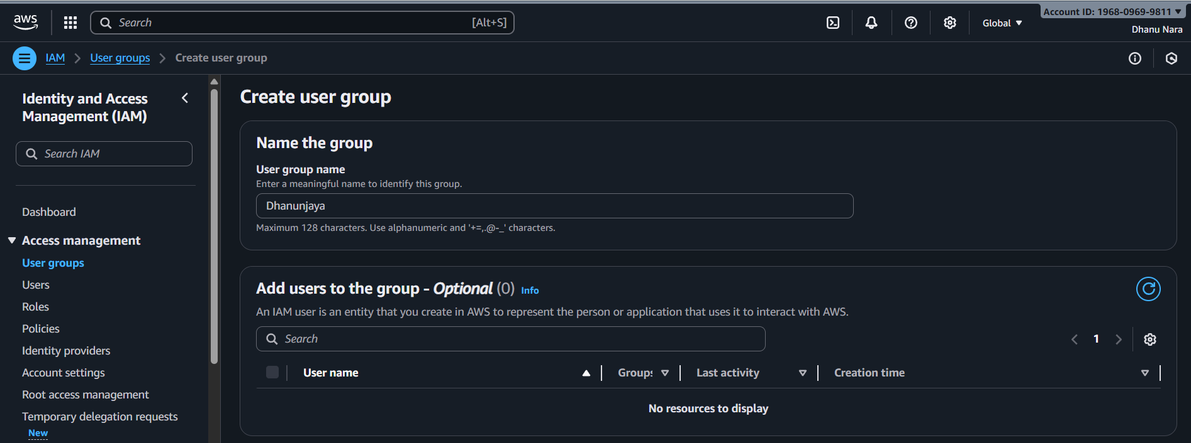
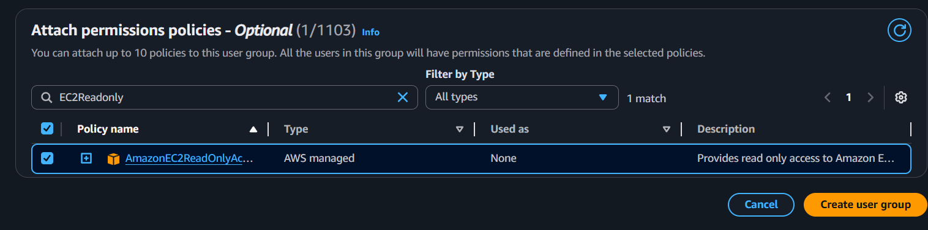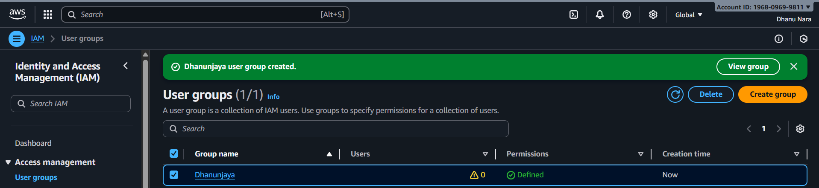

3.Create a new user named “Devops” and add to the group created in task 2.
First we should go to IAM.
Click on create user and enter the user name Devops.
Now go to user groups and click on the user group created for task 2 and select that.
Click on create user.
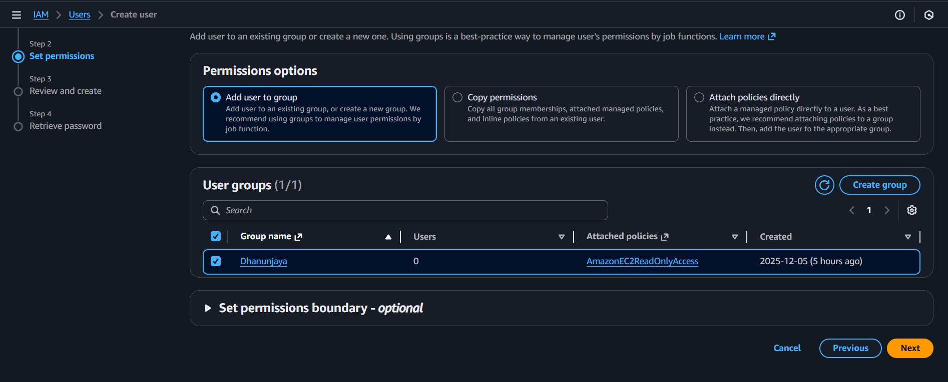
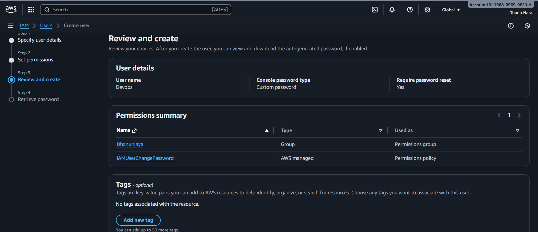
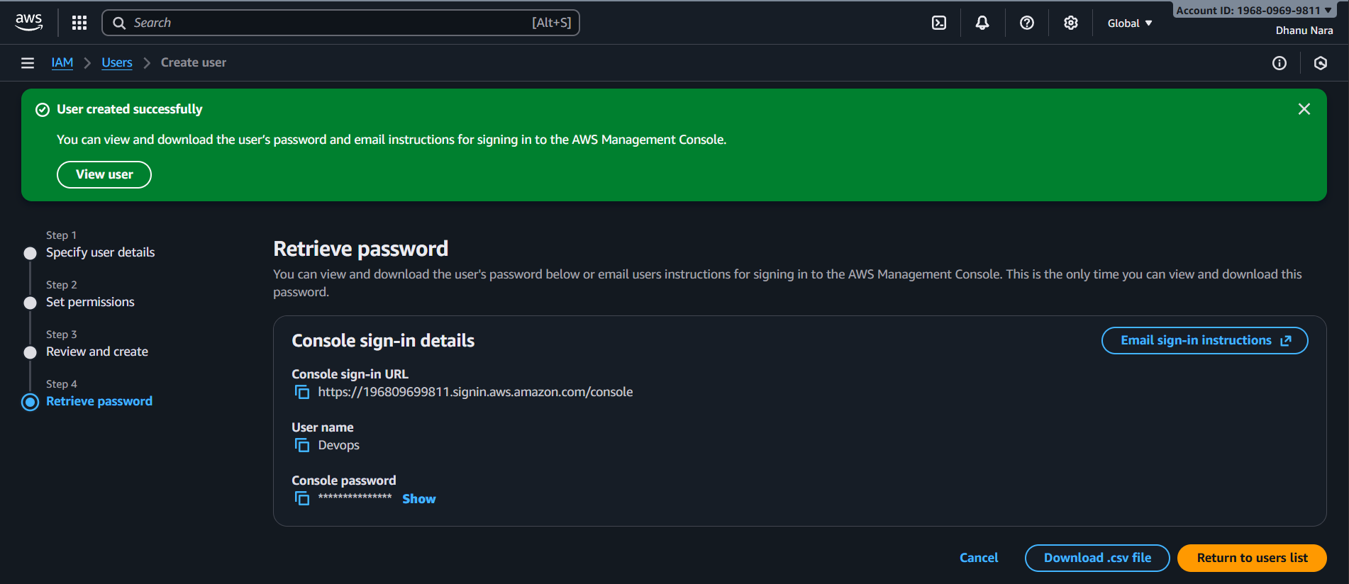
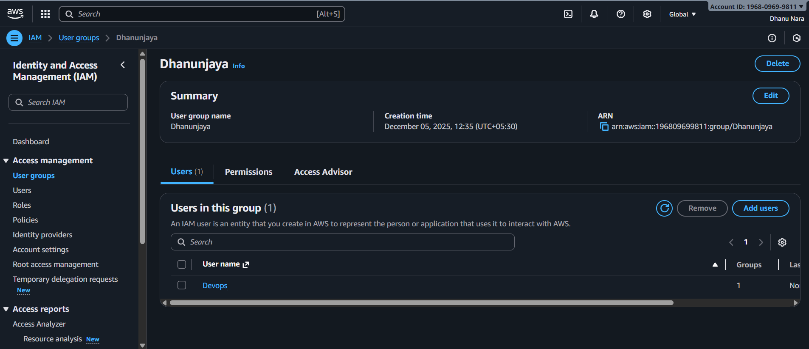

4.Write a bash script to create an IAM user with VPC full access.
First we should go to git bash and there we need to configure AWS.
And fill the script in a file using vi and give the chmod 755 permissions to that.
Now execute the script.
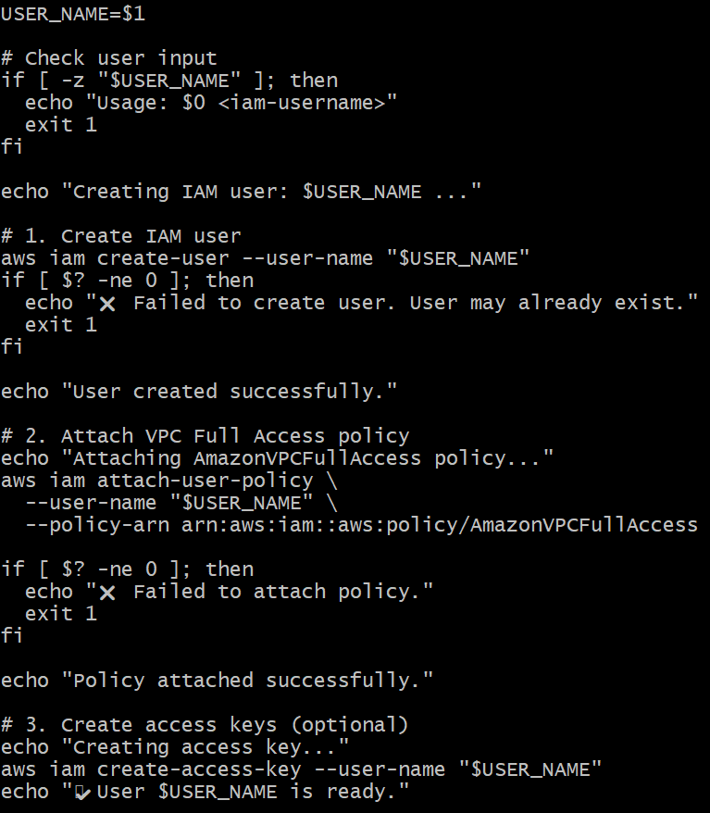
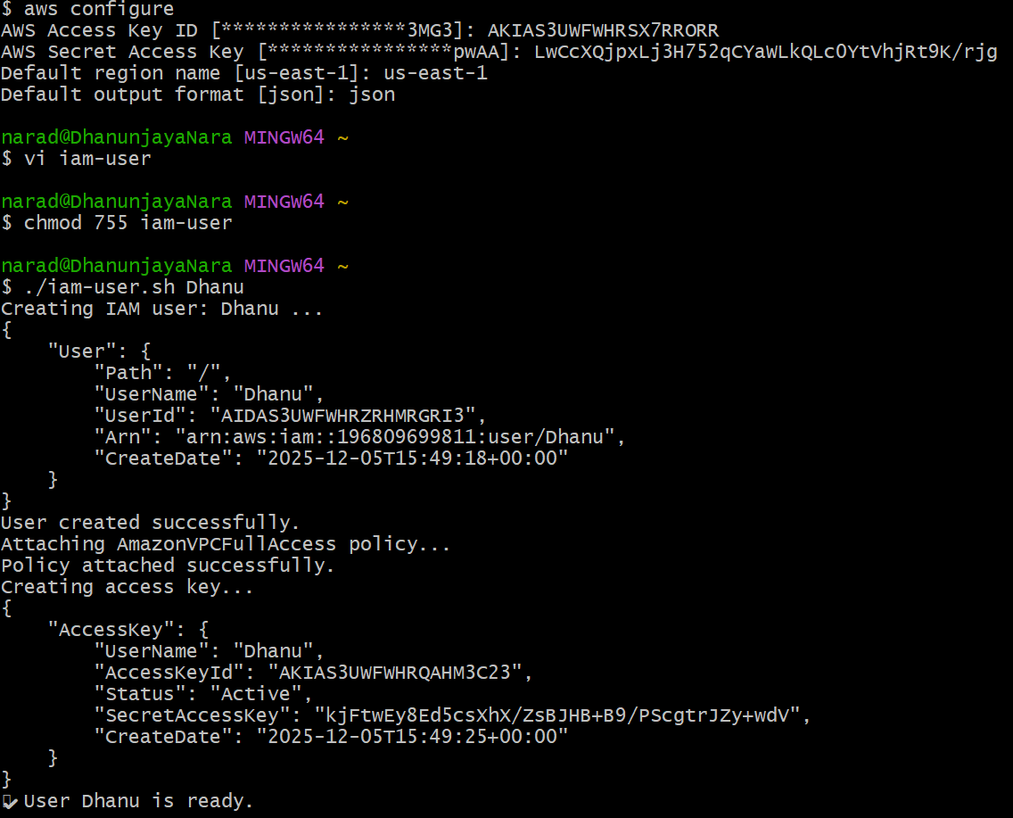

5.Create an IAM policy to allow EC2 access for a specific user in specific regions only.
First we should go to IAM and create a policy
Now go to JSON tab and delete the existing one and paste the policy there
Policy is to allow access only in ap-south-1 & us-east-1, so this policy will EC2 access only in these regions mentioned
Now click on create policy.
Now go to user and create one user
Now select the user and click on add permissions and attach policy directly
Now search for the policy created earlier and select it
Click add on permissions.

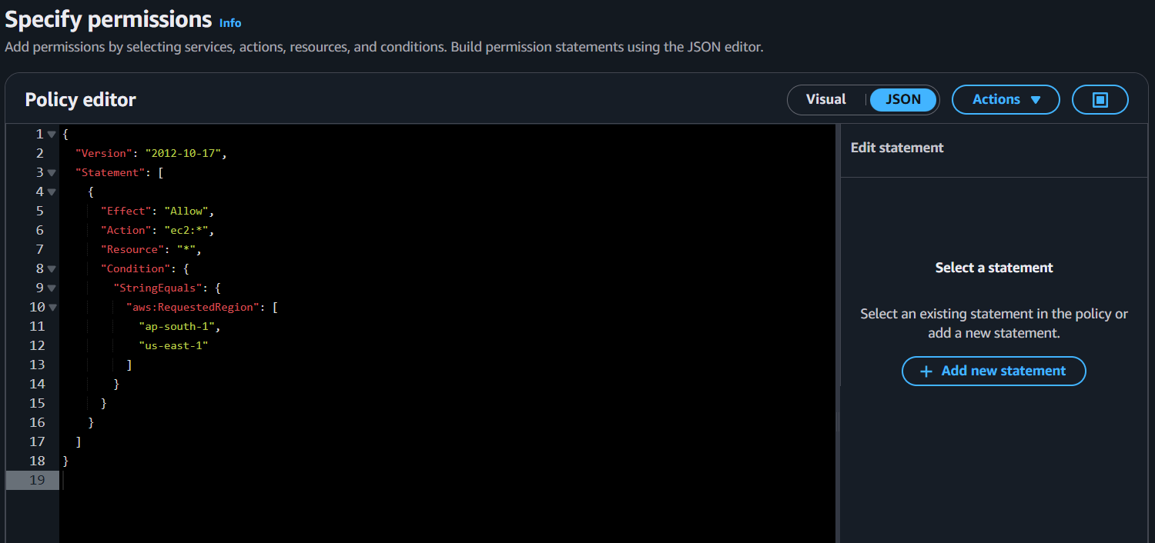
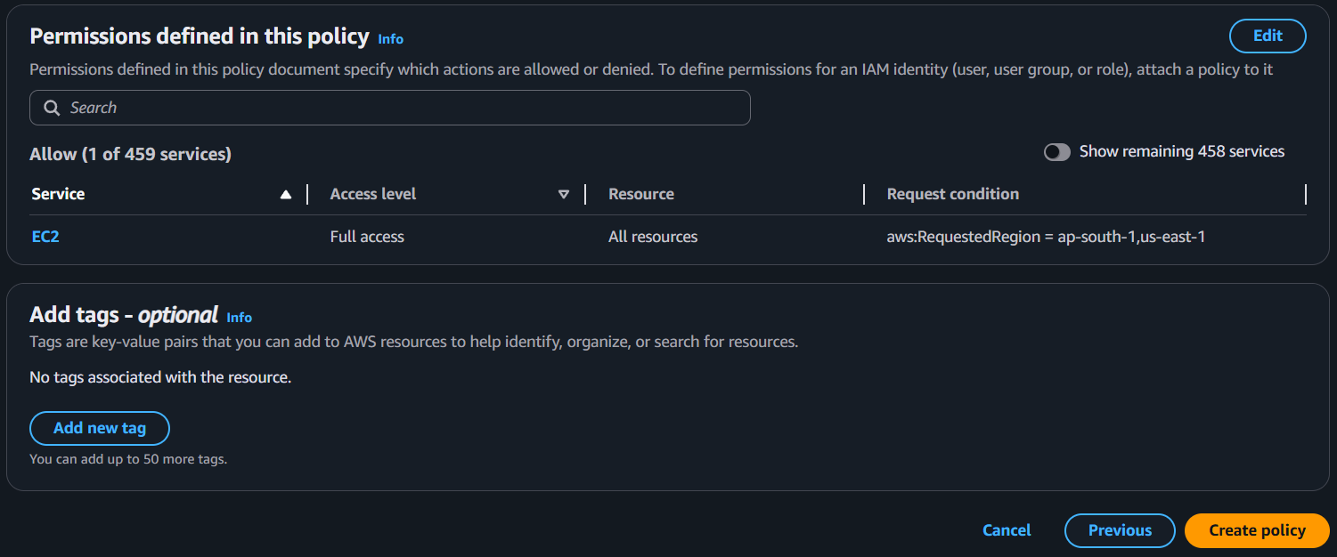
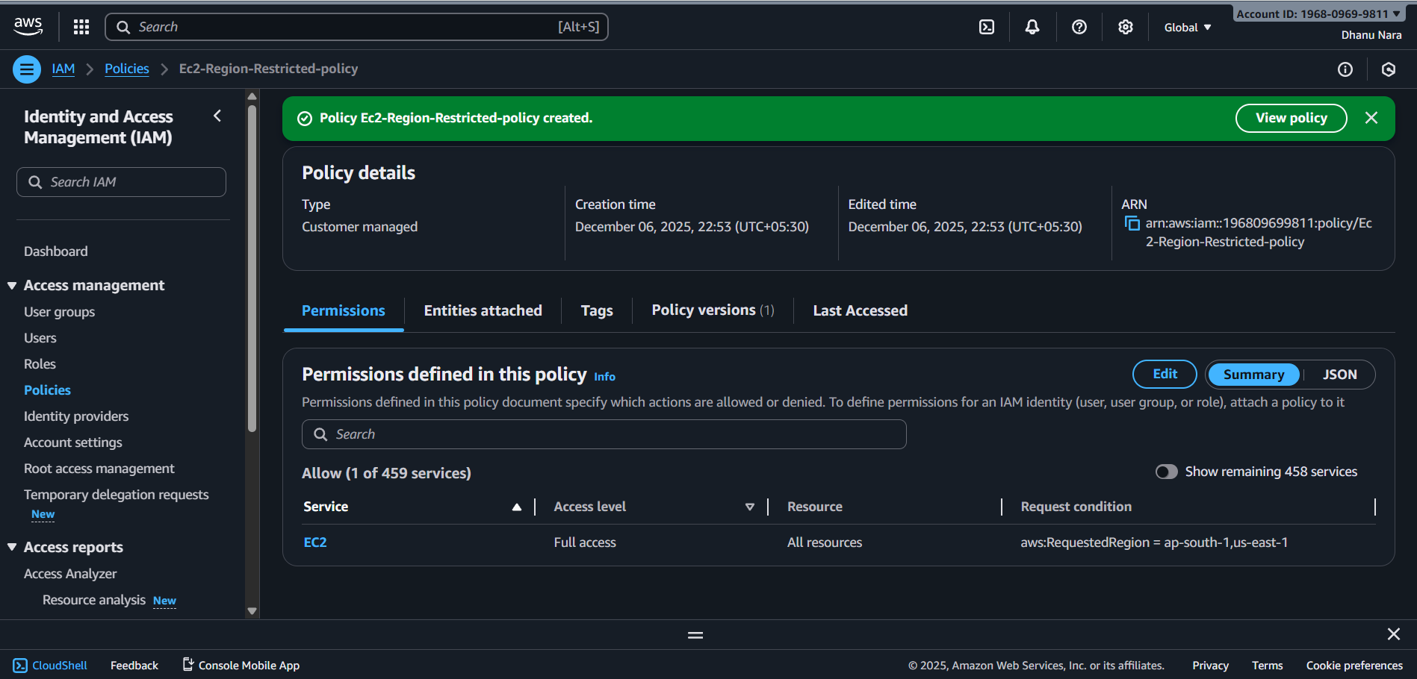
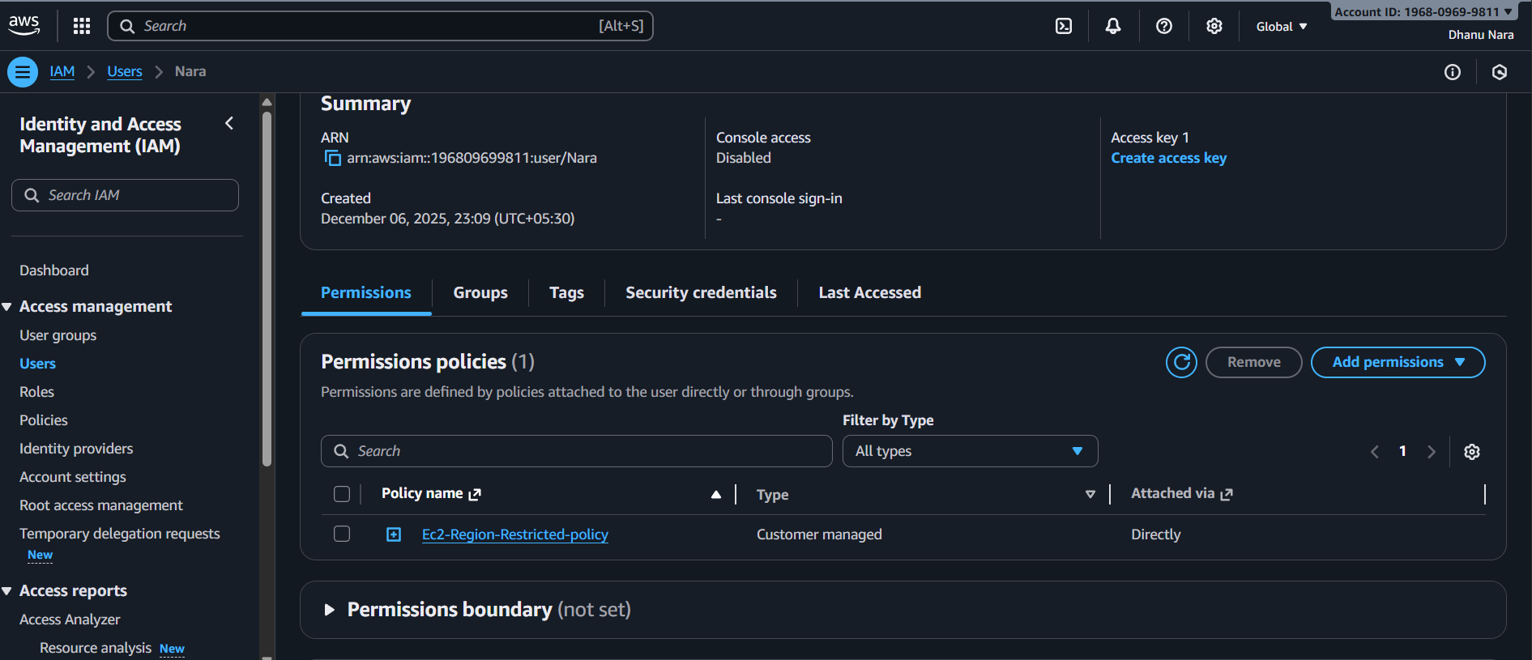

6.We have two accounts: Account A and Account B. Account A user should access an S3 bucket in Account B.
